**‘lPandit Deendayal Energy University**

**School of Technology**

**Department of Computer Science & Engineering**

Odd Semester 2023-2024

**Internet of Things**

**Course file**

|  |  |  |
| --- | --- | --- |
| **Namabe of the course:** | | Internet of Things |
| **Course Code:** | | 23CP403T |
| **Program:** | | B. Tech. |
| **Department:** | | Computer Science and Engineering |
| **Semester:** | | 7th semester |
| **Academic Year:** | | 2024-2025 |
| **Name of Course Coordinator:** | | Dr. Ketan Sabale |
| **Name of Other Faculty Members:** | | Dr. Amit Singh |
|  | | |
| [A] | Teaching Scheme, Lab Experiments, Prerequisites, List of Books and Reference Books. | |
| [B] | Lesson Plan | |
| [C] | Academic Calendar, Faculty Timetable, Class Timetable | |
| [D] | Course Outcomes (COs) | |
| [E] | Mapping of Course Outcomes with Program Outcomes (POs) | |
| [F] | Evaluation Scheme and Rubrics | |
| [G] | Class Notes, Handouts, Course Material, etc. | |
| [H] | Course Presentations (PPTs) | |
| [I] | Tutorials, Assignments, Case Studies, Quiz, etc. | |
| [J] | Course related ICT: Weblinks, Software, E-books, Relevant NPTEL and MOOC, Video lectures, Blogs, Virtual Labs, Animations, Simulations etc. | |
| [K] | Laboratory Manuals | |
| [L] | List of International / National Journals related to the Course | |
| [M] | List of well-known Conferences related to the Course | |
| [N] | List of Classic Journal Papers / Articles / Review Papers related to the Course | |
| [O] | List of Renowned Industries / Organizations / working in the Course related areas | |
| [P] | List of Renowned Scientists / Academicians working in the Course related areas | |
| [Q] | Copies of the MSE and ESE Question Papers and Answer Sheets | |
| [R] | Attendance Record | |
| [S] | Records of the Continuous Assessment (Assignment, Quiz, Laboratory Work, etc.) | |
| [T] | Details of Remedial Classes (with evidences) | |
| [U] | Details of Expert Lectures / Industrial Visits/Events (Only related to the Course) | |
| [V] | List of Slow and Advanced Learners, activity planned and executed | |
| [W] | Direct Assessment (Result of mid, end and internal assessment components) | |
| [X] | Indirect Assessment (Exit Survey/ Post Test) | |
| [Y] | Final Attainment of COs and POs and Interpretation | |
| [Z] | Actions to be taken if COs and POs are not achieved | |

**Date:**

|  |  |  |
| --- | --- | --- |
| **Signature of Subject Teachers** | **Signature of Department Coordinator (IQAC)** | **Signature of Head of the Department** |

# Teaching Scheme, Lab Experiments, Prerequisites, List of Books and Reference Books.

**Teaching Scheme**

|  |  |  |  |  |  |  |  |  |
| --- | --- | --- | --- | --- | --- | --- | --- | --- |
|  | | | | | **Internet of Things** | | | |
| **Teaching Scheme** | | | | | **Examination Scheme** | | | |
| **L** | **T** | **P** | **C** | **Hrs./Week** | **Mid Sem** | **End Sem** | **IA** | **Total** |
| **1** | **0** | **0** | **1** | **1** | **25** | **50** | **25** | **100** |

**Course Syllabus**

|  |  |
| --- | --- |
| **UNIT 1 INTRODUCTION TO INTERNET OF THINGS** | **02 Hrs.** |
| IoT Definition, IoT characteristics, M2M and IoT, End to End IoT Architecture, Physical Design of IoT, Logical Design of IoT, Challenges for IoT, Interdependencies of IoT and cloud computing, web of things. |  |
|  |  |
| **UNIT 2 IOT PROTOCOLS** | **04 Hrs.** |
| Overview of IoT Protocols, Massaging protocols, IPv4, IPv6, Transport Protocol (MQTT), Link Layer Protocols, Network/Internet layer protocols, Transport layer protocols, Application Layer Protocols. |  |
|  |  |
| **UNIT 3 EMBEDDED IOT DEVICES** | **03 Hrs.** |
| Sensors and Actuators for IoT Application, IoT components, Types and configuration of gateways, Specifications of Iot gateway, Digital Twin. |  |
|  |  |
| **UNIT 4 APPLICATION BUILDING WITH IOT** | **04 Hrs.** |
| Various application of IoT: Food, Healthcare, Lavatory maintenance, Water quality, Warehouse, Retail, Driver Assistance, Collision Impact, Case Studies in addition to application building esp manufacturing, asset monitoring, supply chain. |  |
| **Max.** | **13 Hrs.** |

**Pre-requisites courses:**

1. Computer Networks Course.

**Text /Reference Books:**

1. Internet of Things, Vasudevan, Nagrajan and Sundaram, Wiley India.
2. IoT Fundamentals, David Hence et al, Cisco Press
3. 21 IoT Experiments, Yashwant Kanetkar, Shrirang Korde, BPB
4. IoT Based Projects, Rajesh Singh et al, BPB
5. Internet of Things with Arduino and Bolt, Ashwin Pajankar, BPB
6. Star Expert IoT Specialist, STAR Certfication

# Lesson Plan

**Common for All Division**

|  |  |  |  |  |
| --- | --- | --- | --- | --- |
| **Sr. No.** | **Topics To Be Covered** | **Planned Date** | **Conduction Date** | **Mapped CO** |
| 1 | IoT Definition, IoT characteristics, M2M and IoT, End to End IoT Architecture, Physical Design of IoT | 29-07-2024 |  | CO1 |
| 2 | Logical Design of IoT, Challenges for IoT, Interdependencies of IoT and cloud computing, web of things | 05-08-2024 |  | CO2 |
| 3 | Overview of IoT Protocols, Massaging protocols, IPv4, IPv6, Transport Protocol (MQTT) | 12-08-2024 |  | CO4 |
| 4 | Link Layer Protocols | 19-08-2024 |  | CO4 |
| 5 | Network/Internet layer protocols | 26-08-2024 |  | CO4 |
| 6 | Transport layer protocols, Application Layer Protocols | 02-09-2024 |  | CO4 |
| 7 | Sensors and Actuators for IoT Application, IoT components | 09-09-2024 |  | CO3 |
| 8 | Types and configuration of gateways | 16-09-2024 |  | CO3 |
| 9 | Specifications of Iot gateway, Digital Twin | 07-10-2024 |  | CO3 |
| 10 | Various application of IoT: Food, Healthcare, Lavatory maintenanc | 14-10-2024 |  | CO5 |
| 11 | Water quality, Warehouse, Retail, Driver Assistance | 21-10-2024 |  | CO5 |
| 12 | Collision Impact, Case Studies in addition to application building esp manufacturing | 04-11-2024 |  | CO6 |
| 13 | asset monitoring, supply chain | 11-11-2024 |  | CO6 |

# Academic Calendar, Faculty Timetable, Class Timetable

**Academic Calendar 2024-25 (Odd Semester)**

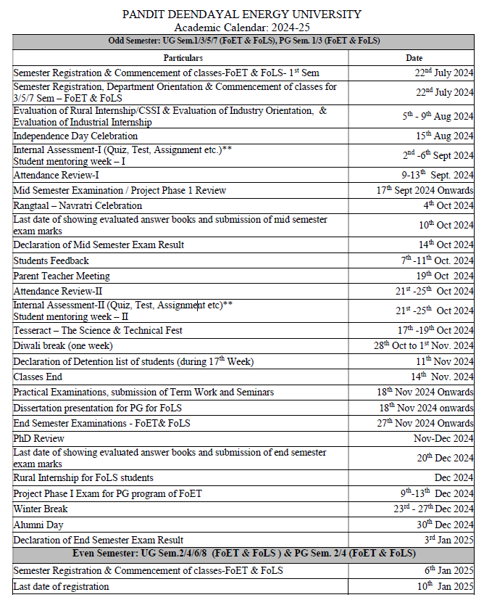

**Faculty Timetable**

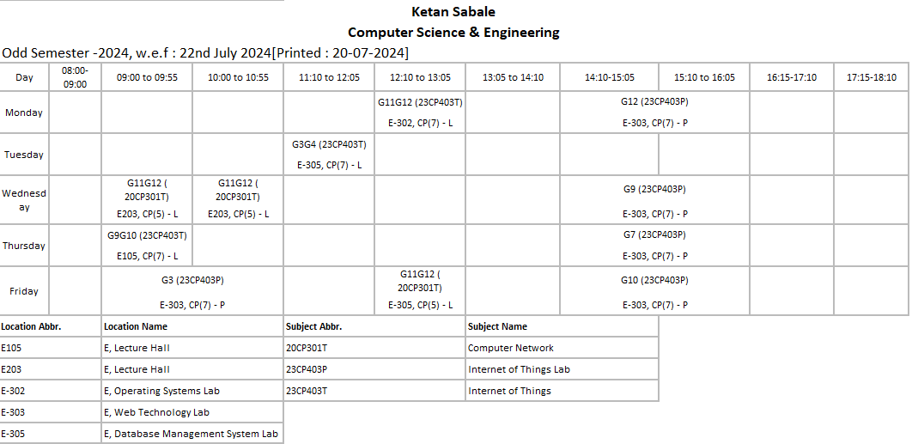

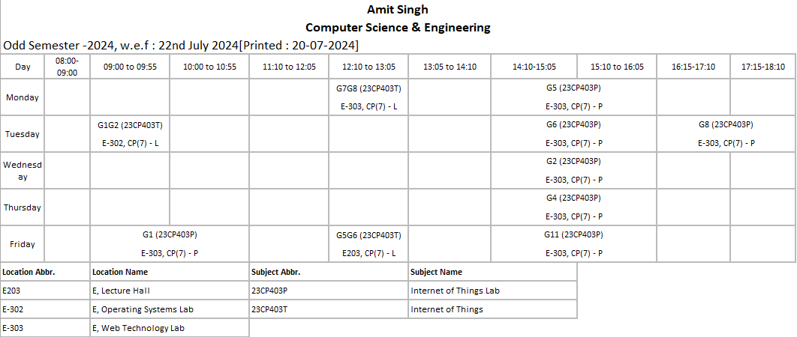

**Class Timetable**

**Division 1**

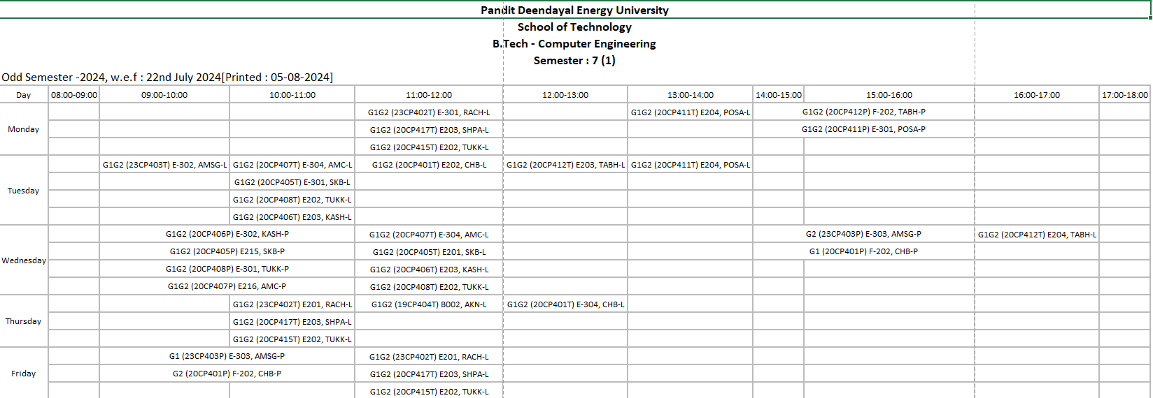

**Division 2**

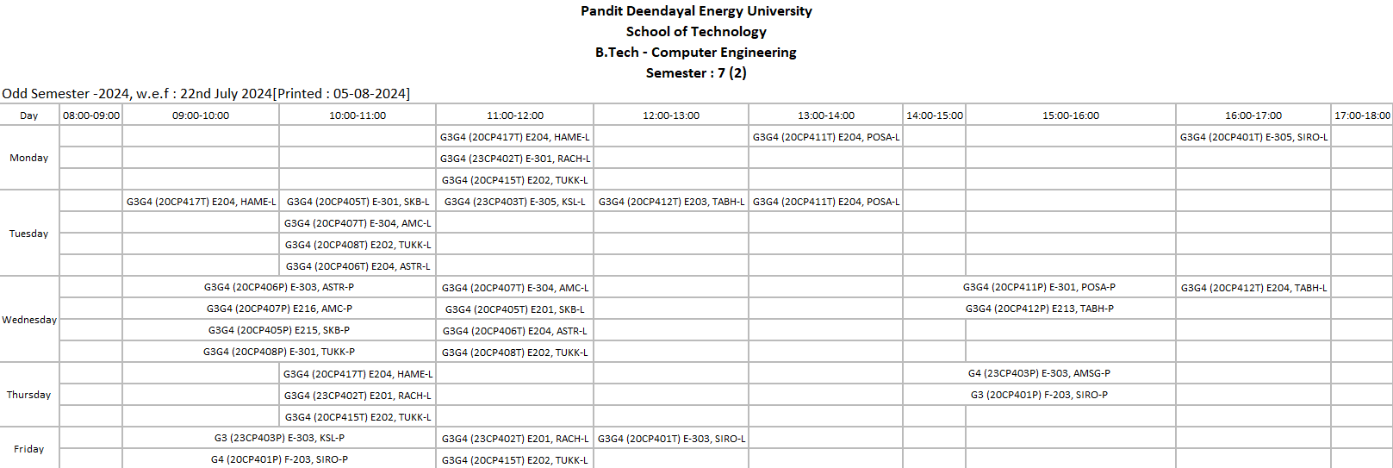

**Division 3**

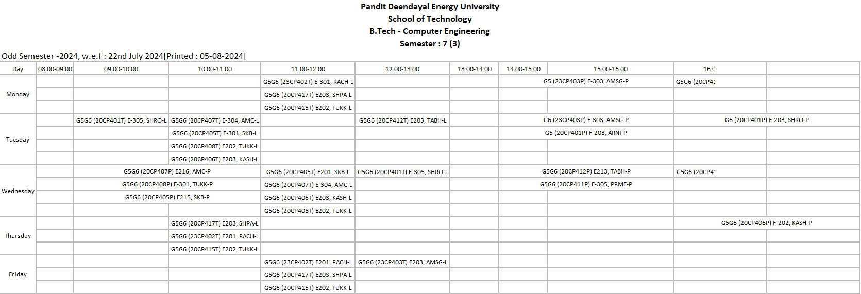

**Division 4**

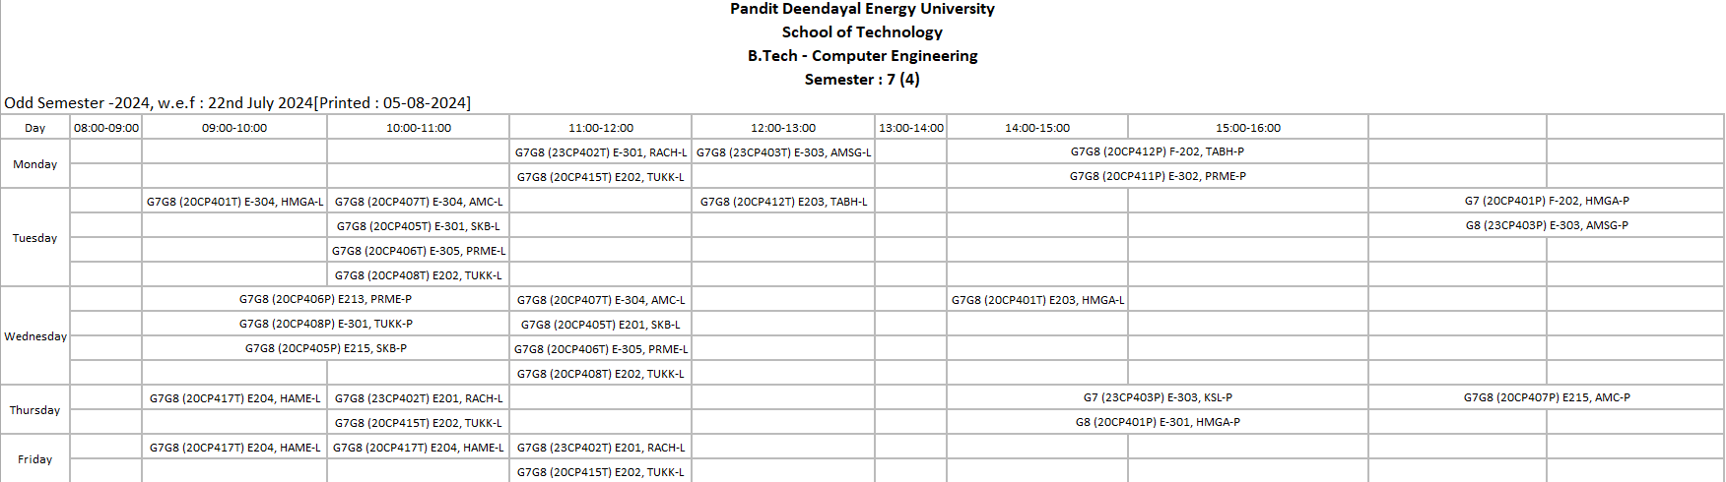

**Division 5**

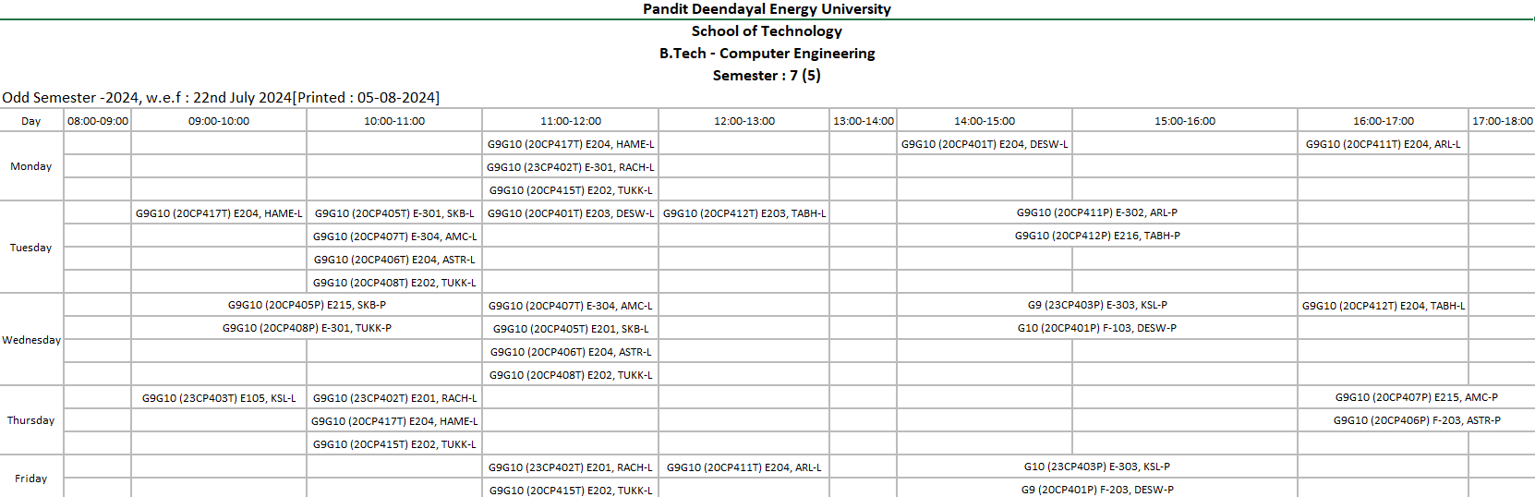

**Division 6**

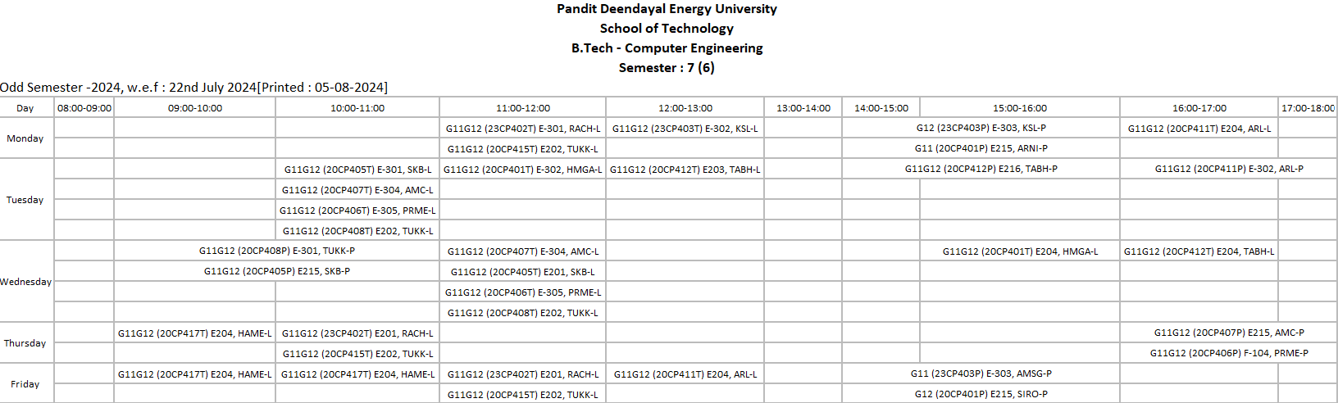

**Student Meeting Hours:**

Dr. Ketan Sabale

Day: Tuesday

Time: 1 PM – 4 PM

Venue: F – R1 – 5th Floor

Dr. Amit Singh

Day: Monday

Time: 4 PM to 6 PM

Venue: E - 216

# Course Outcomes (COs)

On completion of the course, student will be able to

**CO1** - Understand Internet of Things and technological aspects.

**CO2** – Understand the architecture and its relation with available resources

**CO3** - Interpret Interface I/O devices, sensors & Communication modules.

**CO4** – Understand various security aspects for IoT.

**CO5** – Compare different frameworks for implementation.

**CO6** – Design solutions of problems which require IoT as a platform.

# Mapping of Course Outcomes with Program Outcomes (POs)

**Course Articulation Matrix**

|  |  |  |  |  |  |  |  |  |  |  |  |  |  |  |  |
| --- | --- | --- | --- | --- | --- | --- | --- | --- | --- | --- | --- | --- | --- | --- | --- |
| **CO** | **PO 1** | **PO 2** | **PO 3** | **PO 4** | **PO 5** | **PO 6** | **PO 7** | **PO 8** | **PO 9** | **PO 10** | **PO 11** | **PO 12** | **PSO 1** | **PSO 2** | **PSO3** |
| 1 | 3 | 3 | 1 | 1 | - | 2 | - | - | 1 | 2 | - | 2 | 3 | - | 1 |
| 2 | 3 | 2 | 2 | 2 | - | - | - | - | 2 | 1 | - | 1 | 3 | - | 1 |
| 3 | 3 | 1 | 3 | 3 | 3 | 2 | - | - | 3 | 2 | - | 3 | 3 | 2 | 2 |
| 4 | 3 | 1 | 3 | 3 | 1 | 2 | - | 3 | 2 | 2 | - | 2 | 3 | 1 | 3 |
| 5 | 2 | 2 | 2 | 3 | 3 | 1 | - | - | 3 | 2 | - | 3 | 2 | 3 | 3 |
| 6 | 3 | 3 | 3 | 2 | 3 | 2 | - | 1 | 3 | 3 | - | 3 | 3 | 1 | 3 |

**Program Articulation Matrix**

|  |  |  |  |  |  |  |  |  |  |  |  |  |  |  |
| --- | --- | --- | --- | --- | --- | --- | --- | --- | --- | --- | --- | --- | --- | --- |
| **PO 1** | **PO 2** | **PO 3** | **PO**  **4** | **PO 5** | **PO 6** | **PO 7** | **PO 8** | **PO 9** | **PO 10** | **PO 11** | **PO 12** | **PSO 1** | **PSO 2** | **PSO 3** |
| 2.83 | 2 | 2.33 | 2.33 | 2.5 | 1.8 | - | 2 | 2.33 | 2 | - | 2.33 | 2.83 | 1.75 | 2.16 |

Correlation levels 1, 2 and 3 as defined below:

1: Slight (Low) 2: Moderate (Medium) 3: Substantial (High)

# Evaluation Scheme and Rubrics

|  |  |  |  |  |  |
| --- | --- | --- | --- | --- | --- |
| **Assessment Method** | **Assessment Tool** | **Description** | **Marks** | **Mapping with CO** | **Contribution to CO’s** |
| Direct | Mid Semester Examination | Unit 1 and Unit 2 | 50 | CO-1 & CO-2 | It contributes to 25% weightage of Direct Assessment to CO attainment. |
| Internal Evaluation | Quiz, Assignment, Test | 25 | All CO’s | It contributes to 25% weightage of Direct Assessment to CO attainment. |
| Direct | End Semester Examination | **Topics to be covered:**  Unit 1,  Unit 2,  Unit 3 and Unit 4 | 100 | All CO’s | It contributes to 50% weightage of Direct Assessment to CO attainment. |

# Class Notes, Handouts, Course Material, etc.

Class Notes are uploaded on MS Teams when the topic is finished in class.

# Course Presentations (PPTs)

Presentations for this course are prepared from **Internet of Things, Vasudevan, Nagrajan and Sundaram, Wiley India.**

Class Notes are uploaded on MS Teams when the topic is finished in class.

# Tutorials, Assignments, Case Studies, Quiz, etc.

**Internal Assessment 1**

**Subject: Internet of Things**

**Date: 29/08/2023 Total Marks: 10**

1. Explain the logical architecture for a Smart Irrigation System in the context of IoT. **[4 Marks]**
2. What is the difference between monitoring home surveillance using Internet of Things and a central server? **[3 Marks]**
3. a) Can MQTT work on a Local Area Network (LAN)?
4. Can an MQTT message be broadcast to all clients?
5. Is MQTT a good choice for high-speed data transfer? **[3 Marks]**

# Course related ICT: Weblinks, Software, E-books, Relevant NPTEL and MOOC, Video lectures, Blogs, Virtual Labs, Animations, Simulations etc.

Materials from national and international levels like NPTEL, MIT etc., are shared related to the course domain.

1. NPTEL: <https://onlinecourses.nptel.ac.in/noc19_cs65/preview>
2. MIT: <https://web.mit.edu/professional/digital-programs/courses/IoT/phone/index.html>

Video Lectures Series:

INTRODUCTION TO INTERNET OF THINGS:

<https://youtu.be/WUYAjxnwjU4>

.

# Laboratory Manuals

Not applicable for theory course.

# List of International / National Journals related to the Course

Following are the reputed international journals related to the course:

1. INTERNET OF THINGS – Elsevier
2. ACM TRANSACTIONS ON INTERNET OF THINGS
3. IEEE INTERNET OF THINGS JOURNAL
4. IEEE ACCESS

# List of well-known Conferences related to the Course

Following are the list of well-known conferences related to the course:

1. International Conference on IoT, Intelligent Computing and Security
2. IEEE International Conference on Internet of Things and Intelligence System
3. International Conference on Big data, Machine Learning and IOT
4. ETSI IoT Conference

# List of Classic Journal Papers / Articles / Review Papers related to the Course

1. Jinyuan Xu, Baoxing Gu and Guangzhao Tian. Review of Agricultural IoT Technology. Artificial Intelligence in Agriculture. vol. 6. pp. 10-22, 2022.
2. Iqbal H. Sarker, Asif Irshad Khan, Yoosef B. Abushark & Fawaz Alsolami. Internet of Things (IoT) Security Intelligence: A Comprehensive Overview, Machine Learning Solutions and Research Directions. Mobile Networks and Applications, vol. 28 no. 1, pp. 296-312, 2023.
3. Nipuna Chamara, Md Didarul Islam, Geng (Frank) Bai, Yeyin Shi, Yufeng Ge. Ag-IoT for crop and environment monitoring: Past, present, and future. Agricultural systems, vol. 203, pp. 103497, 2022.
4. Quy Vu Khanh, Nam Vi Hoai, Linh Dao Manh, Anh Ngoc Le and Gwanggil Jeon. Wireless Communication Technologies for IoT in 5G: Vision, Applications, and Challenges. Wireless Communications and Mobile Computing, vol. 2022, pp.1-12, 2022.

# List of Renowned Industries / Organizations / working in the Course related areas

Following are the institutes/ organizations that are working in the course related areas:

1. CISCO
2. Honeywell International, Inc.
3. Siemens
4. Verizon Communications

# List of Renowned Scientists / Academicians working in the Course related areas

1. Dr. Antony Franklin, Associate Professor, Department of Computer Science and Engineering, Indian Institute of Technology Hyderabad
2. Dr. Manas Khatua, Assistant Professor, Department of Computer Science and Engineering, Indian Institute of Technology Guwahati
3. Dr. Amitangshu Pal, Assistant Professor, Department of Computer Science and Engineering, Indian Institute of Technology, Kanpur
4. Dr. Ayon Chakraborty, Assistant Professor, Department of Computer Science and Engineering, Indian Institute of Technology, Madras

# Copies of the MSE and ESE Question Papers and Answer Sheets

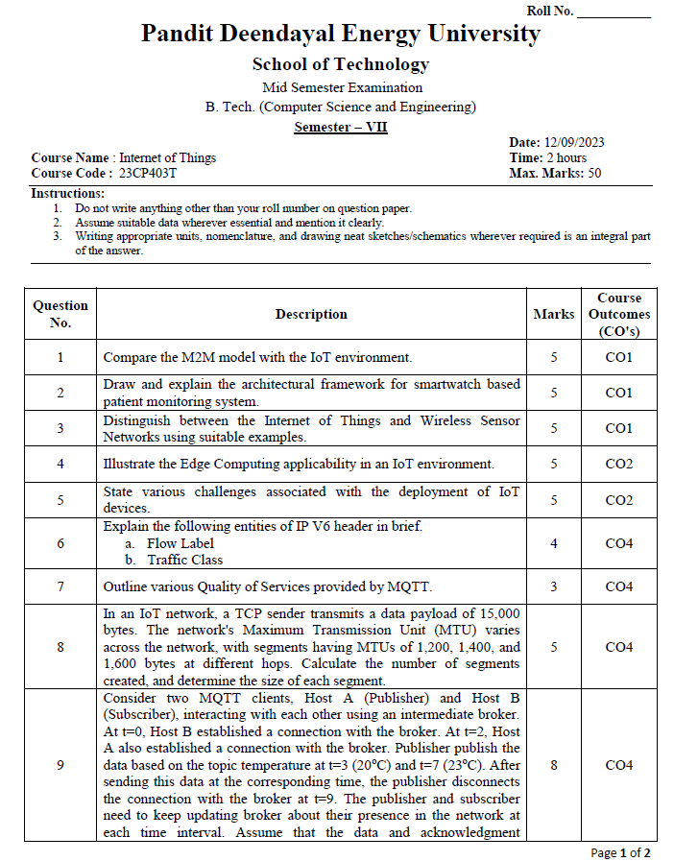

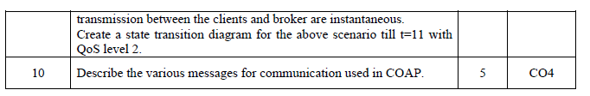

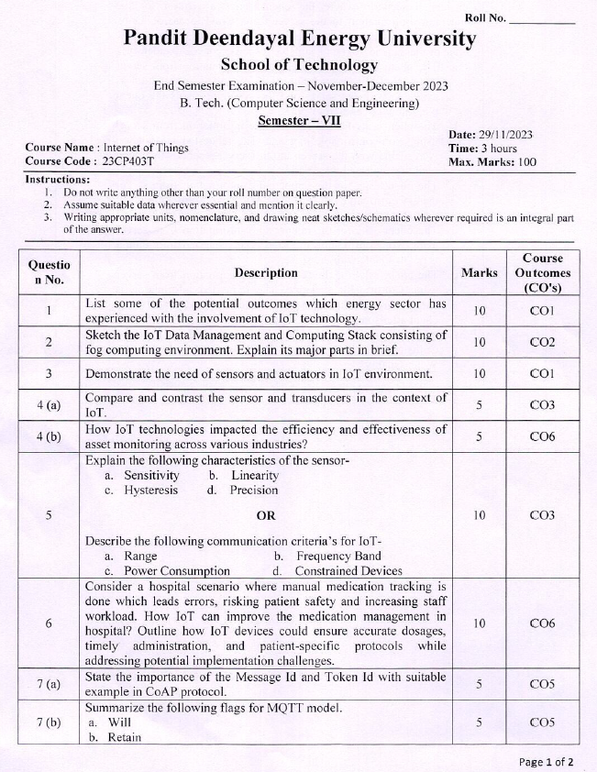

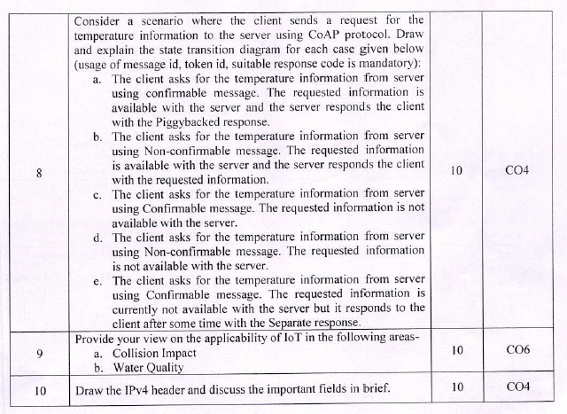

# Attendance Record

# Records of the Continuous Assessment (Assignment, Quiz, Laboratory Work, etc.)

# Details of Remedial Classes (with evidences)

**Attendance of Remedial Class**

**Attendance of Remedial Classes is attached with the course file**

**Topics Covered in Remedial Classes**

# Details of Expert Lectures / Industrial Visits/Events (Only related to the Course)

Not applicable for this course.

# List of Slow and Advanced Learners, activity planned and executed

# Direct Assessment (Result of mid, end and internal assessment components)

# Indirect Assessment (Exit Survey/ Post Test)

# Final Attainment of COs and POs and Interpretation

# Actions to be taken if COs and POs are not achieved